Video Demo can be found at:

http://www.4shared.com/document/1KBHY6oK/Kyle_Thornton_Picasa_Chatter_E.html

Install the package with following URL:

https://login.salesforce.com/?startURL=%2Fpackaging%2FinstallPackage.apexp%3Fp0%3D04tE00000000RMG

Password for package install : cloudspokes

Package includes document on installation and configuration as well as explanation of features.

# Configuring your Picasa Chatter Trigger

You first need to ensure that your Picasa account is configured to accept images via email.

1. Navigate to your Picasa account, click the gear in the top right corner and open the photo settings  
   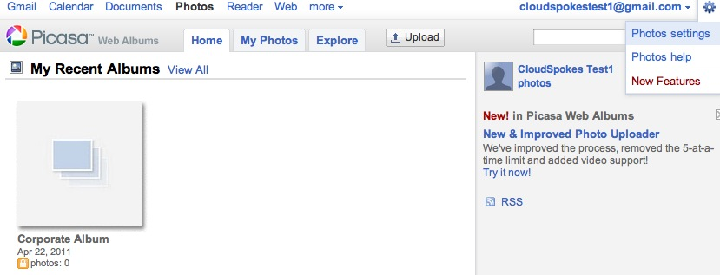
2. Check the box in the Upload photos by email and enter a secret word. You will see the email address below change as you enter the secret word. The email address is a combination of your gallery URL extension plus the secret word, so you may want to configure your gallery URL as well.   
   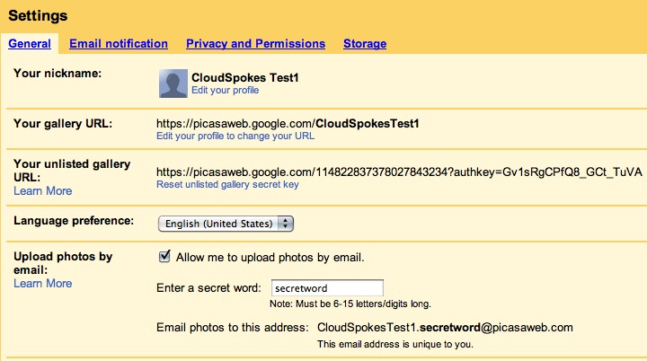
3. Once you have configured your Picasa account you need to configure the custom settings for the trigger. In Salesforce.com, navigate to:  
     
   *your name* > Setup > Develop > Custom Settings  
     
   Find the Picasa Settings and click Manage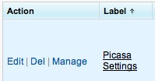
4. Click New and enter the details for your custom setting and Save.
   1. Name – This can be a descriptive name, anything you choose.
   2. Active – Check this box to tell the trigger to read this custom setting
   3. Picasa Email Address – The address configured in step 2
   4. Keyword – The keyword which, when found in the desciption, tells the trigger to email an image to the email entered in Picasa Email Address. **Tip: if you enter your keyword using a hash tag (#) you will gain the advantage of Trending so you can see all of the images that have been uploaded to picasa just by viewing that hash tag.**
   5. Allow Album Loading – Checking this box will allow users to define the album in the picasa account where the email will be inserted. To use this feature, you must enter the album name in square brackets directly after the keyword and a colon. The format would be *keyword:[Album Name]*

# Using the Trigger on a FeedItem

In order to cause the trigger to fire, navigate to any record in your org for which you have chatter enabled. Add a file to the Chatter feed. In the description, include your keyword. Optionally, if the feature has been enabled, include an album name after the keyword using the following syntax:  
 *keyword*:[*Album Name*]

For example, if your Picasa account has an album named “Corporate Album” and your keyword is #picasa then your upload would look like this:

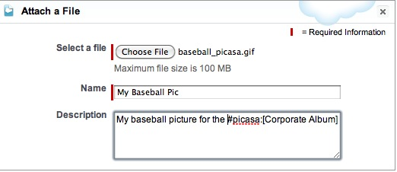

Click share and the trigger will take over. Within 30 seconds you should see your image appear in your Picasa account under the Corporate Album.

If you choose not to add the photo to a specific album by only entering “#picasa” then the image will be placed in the Drop Box of the Picasa account and in the above case would have a caption of “My Baseball Pic.” Note that you can either add the image to an album with no caption or add it to the drop box with a caption, but you cannot add an image to a specific album **with** a caption.

# Using the Trigger with a FeedComment

If you forget to add the file to the picasa web album or you see an image you would like to upload you can simply add a comment to the Chatter Feed with the keyword and optionally, if the feature has been enabled, the album name. To add a picture to an preconfigured album in the Picasa account, enter the keyword followed by a colon and the name of the album in square brackets. For example, if the keyword is #picasa and you want to add a picture to the “Halloween Party” album, then you can add a comment to the photo like this:  
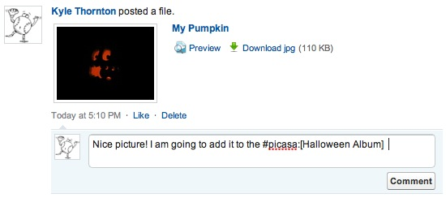

Click the Comment button and the trigger will take over. Within 30 seconds you should see your image appear in your Picasa account under the Halloween Album.